Franklin Horner Community Centre Woodshop
432 Horner Ave, Etobicoke, ON M8W 2B2 (416) 252-6822 email: franklinhorner.inquiries@gmail.com

A woodshop for the hobbyist woodworker

Courses
The woodshop offers courses throughout the year including beginner courses to help potential members successfully complete the safety focused test required for membership.

Woodworkers must pass a safety test focused on the safe operation of the machines. In addition to joining the woodshop and agreeing to its rules, members must also join the Franklin Horner Community Centre and abide by its policies.
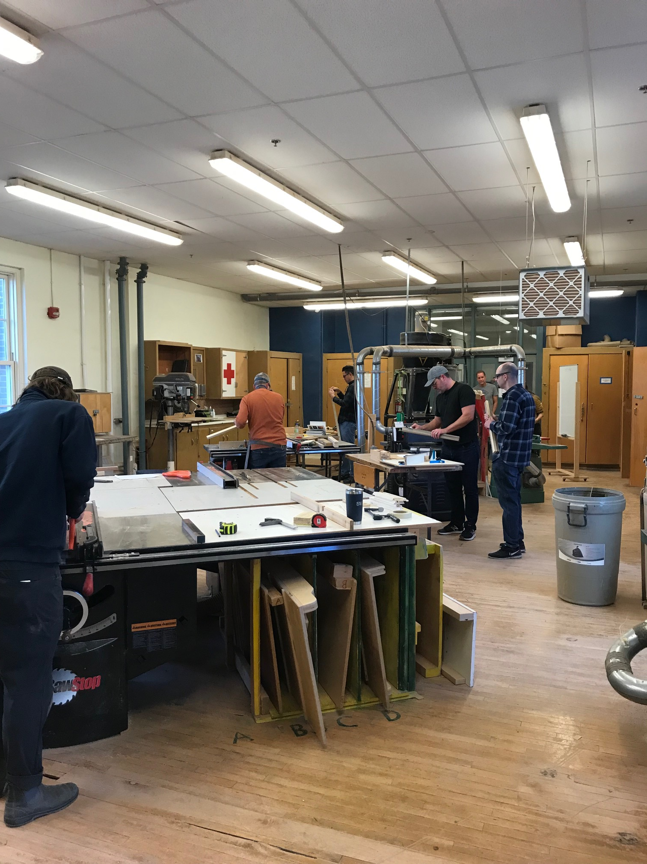

Equipment
Members enjoy the use of Sawstop cabinet saws, band saws, drill presses, routers and router tables, mitre saw, 8 inch jointer, 20 inch planer, sanding room complete with belt and drum sander as well as various hand sanders, finishing room, assembly rooms with work benches, clamps and hand tools and lathe room.
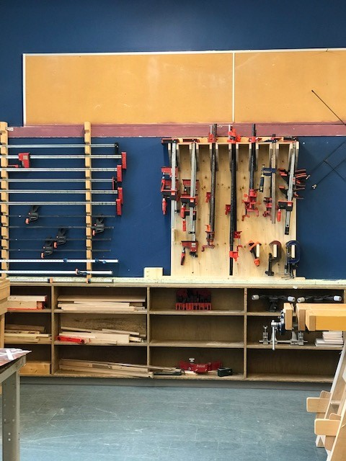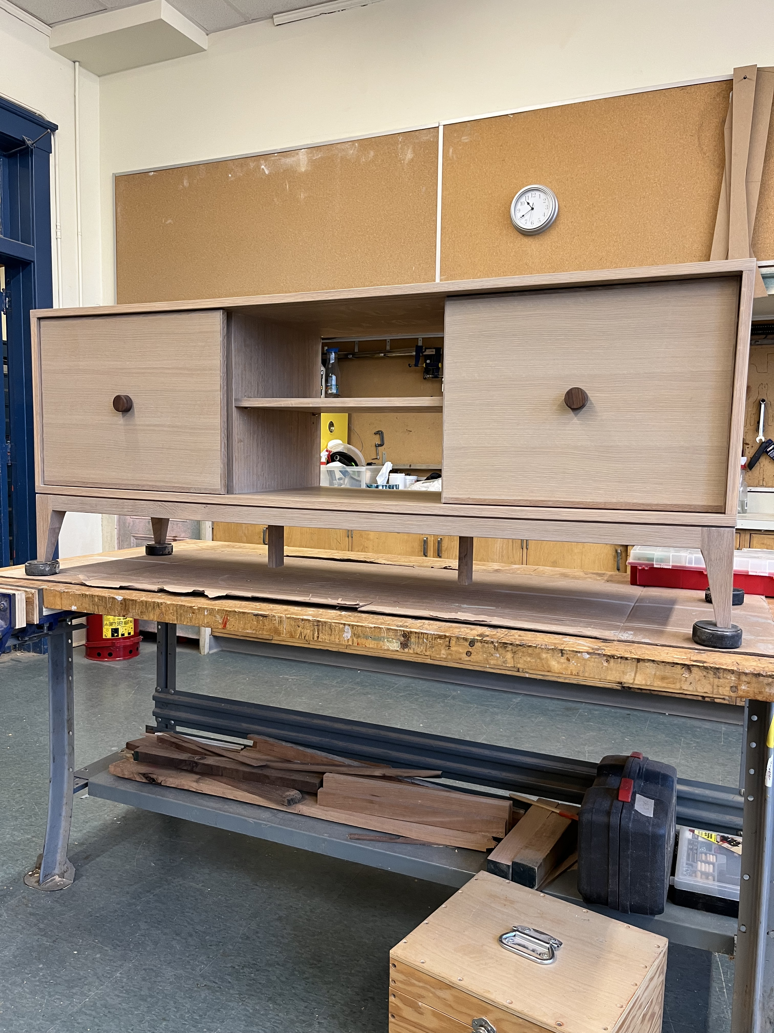

The shop is equipped with two Sawstop table saws, a Sawstop dado saw, jointer, thickness planer, band saws, jig saw, router, sanding room, various small hand and power tools and lots of clamps. Some space is provided for work in progress.

The shop is run by the members, there is no dedicated supervisor, so it is important for us to know that everyone who is using the shop is competent. Members are expected to make sure that the shop is maintained, kept clean and in good order. Note: This is a shop for hobbyist woodworkers only. No commercial work allowed.

We also offer basic woodworking courses. The 100A and 100B focus on the machinery in the shop and are primarily about safe use. For more information or to get on the waiting list for these courses, please contact us at franklinhorner.inquiries@gmail.com

Franklin Horner Community Centre Woodshop
432 Horner Ave, Etobicoke, ON M8W 2B2 (416) 252-6822 email: franklinhorner.inquiries@gmail.com

Shop Hours
Monday - Thursday 8AM to 9PM
Friday 9AM – 3PM
Saturday and Sunday -9AM to 3:30PM

How to Join - To become a member and to have access to the shop, you must pass a woodshop safety test. It is a purely practical test. It requires the candidate to understand the function and safe use of the major shop machines: mitre saw, jointer, planer, table saw, drill press, router, and band saw. In the test you are given a piece of rough lumber and a template and are asked to reproduce the template. This is not a test of woodworking skill, it is a review of how safely the equipment is set-up and operated and the order in which the operations are performed. You must provide your own eye protection, tape measure and pencil.

Self-Assessment Questions
- Do you have experience dimensioning rough-cut lumber to finished size?
- Are you familiar with operating a jointer and thickness planer?
- Can you set up a router and profile an edge using the router table?
- Are you familiar with using relief cuts on the band saw?
- Can you break out rough lumber on a table saw?
- Are you familiar with the difference between cross cutting and ripping on the table saw?
- Can the fence be used to support the work piece when cross cutting on the table saw?
Test Fee $50 – must be paid in advance in person at the office during office hours or online at: franklinhorner.finance@gmail.com

Membership Fee - A successful candidate must be a member of the Franklin Horner Community Centre ($35 per year) and pay the woodshop user fee ($350 per year) to have access to the shop. Both fees are calendar year and renew in December. Payable in person at the office or online at franklinhorner.finance@gmail.com

Successful candidates must attend a Shop Orientation session before receiving membership.

How to Schedule a Test - contact Office @ franklinhorner.finance@gmail.com Phone: (416) 252-6822

Please note that this is a hobbyist shop and is not for commercial work.

